DareIT
A Project Report Submitted
in Partial fulfillment of the Requirements
for the Degree of
MASTER OF COMPUTER APPLICATION
by
PULKIT ARORA
(Enrollment no. 1900290149075)

Under the Supervision of
Mr Ankit Verma
KIET Group of Institutions, Ghaziabad

to the
Department of Computer Applications
Dr. A.P.J. ABDUL KALAM TECHNICAL UNIVERSITY
LUCKNOW
(Formerly Uttar Pradesh Technical University, Lucknow)
May 2021

Table of content

 | Page No.
Declaration | i
Certificate | ii
Abstract | iii
Acknowledgement | iv
List of Figures | v
CHAPTER 1: INTRODUCTION | 1-5
1.1 Project Title | 1
1.2 Project Description | 1
1.3 Project Scope | 2
1.4 Hardware/Software used in Project | 2
1.5 Project Schedule (GANTT CHART) | 3
1.6 Project Requirements | 3
1.7 User Characteristics | 4
1.8 Constraints | 4
1.9 Project Schedule (GANTT CHART) | 5
CHAPTER 2: LITERATURE REVIEW | 6-32
2.1 What is Angular | 6
2.2 Features of Angular 8 | 8
2.3 Architecture of Angular | 10
2.4 The Angular Market | 12
2.5 Obtaining the required tools | 18
2.5.1Visual Studio | 22
2.5.2 Angular Fire | 26
2.5.3 Browser support | 30
2.5.4 CREATING NEW PROJECT | 31
2.6 Operating System for ANGULAR 8 Development | 32
CHAPTER 3: TECHNICAL FEASIBILITY | 33-39
3.1 Feasibility Study | 33
3.2 Technical Feasibility | 34
3.3 Economical feasibility | 35
3.4 Operational Feasibility | 36
3.5 Schedule feasibility | 37
3.6 TECHNOLOGY DESCRIPTION | 37
3.7 TECHNOLOGY USED IN THE PROJECT | 37
3.7.1 ANGULAR | 38
3.7.1.1 FEATURES OF ANGULAR | 38
3.7.1.3 EXPRESSIVE AND FLEXIBLE UI | 39
3.7.1.4 NATIVE PERFORMANCE | 39
3.7.1.5 CATEGORIES OF ANGULAR | 39
3.7.1.6 ENVIRONMENT SETUP | 39
CHAPTER 4: BACKEND DESIGN | 40-43
4.1 Data Flow Diagram | 40
4.1.1 DFD Components | 40
4.1.1.1 Process | 41
4.1.1.2 Data Flow | 41
4.1.1.3 Warehouse | 42
4.1.1.4 Terminator | 42
4.2 DFD of the Project | 43
4.2.1 Level 0 DFD | 43
4.2.2 Level 1 DFD | 43
CHAPTER 5: FRONTEND DESIGN | 44-60
5.1 Splash Screen | 44
5.2 HOME SCREEN | 45
5.3 Login Screen | 46
5.4 REGISTRATION SCREEN | 47
5.5 DASHBOARD | 48
5.6 Dare/Challenge LIST | 49
5.7 Dare Creation Page | 50
5.8 Challenge Creation Page | 53
5.9 Challenge Creation Page | 54
5.10 Landing Pages | 55
5.11 Vote Page | 56
5.12 USER LIST | 57
5.13 USER PROFILE | 59
5.14 DareIT Arena Dashboard | 60
CHAPTER 6: TESTING | 61-68
6.1 Definition of Quality | 60
6.2 Importance of Quality | 60
6.3 Managing Quality | 61
6.4 MOBILE TESTING | 62
6.5 TEST STRATEGY | 63
6.5.1 Universal Rules | 63
6.6 Test Design | 64
6.7 Approach Overview | 64
6.7.1 Pre-processing | 64
6.7.2 Test case Optimization | 64
6.7.3 Screening Key Variable | 65
6.7.4 Bug Localization | 65
6.8 UI Testing | 65
6.9 Performance Testing | 65
6.10 TESTING OBJECTIVES | 66
6.10.1 UNIT TESTING | 66
6.10.2 SYSTEM TESTING | 67
6.10.3 INTEGRATION TESTING | 67
6.10.4 WHITEBOX TESTING | 68
6.10.5 BLACKBOX TESTING | 68
CHAPTER 7: ANGULAR SECURITY | 69-76
7.1 Security | 69
7.2 Preventing cross-site scripting (XSS) | 69
7.3 Angular’s cross-site scripting security model | 70
7.4 Sanitization and security contexts | 71
7.5 Direct use of the DOM APIs and explicit sanitization calls | 72
7.6 Trusting safe values | 73
7.7 Content security policy | 74
7.8 Use the AOT template compiler | 75
7.9 Server-side XSS protection | 76
7.10 HTTP-level vulnerabilities | 76
CHAPTER 8: LIMITATIONS | 77
8.1 Limitations | 72
8.2 Future Scope | 72
8.3 Future Enhancement | 72
CHAPTER 9: CONCLUSION | 78
CHAPTER 10: REFERENCES | 79-80

DECLARATION
I hereby declare that the work presented in this report entitled “DareIT”, was carried out by me. I have not submitted the matter embodied in this report for the award of any other degree or diploma of any other University or Institute.
I have given due credit to the original authors/sources for all the words, ideas, diagrams, graphics, computer programs, experiments, results, that are not my original contribution. I have used quotation marks to identify verbatim sentences and given credit to the original authors/sources.
I affirm that no portion of my work is plagiarized, and the experiments and results reported in the report are not manipulated. In the event of a complaint of plagiarism and the manipulation of the experiments and results, I shall be fully responsible and answerable.

Name : Pulkit Arora
Roll. No. : 1900290149075
Branch : Master of Computer Application


(Candidate Signature)
Training Certificate

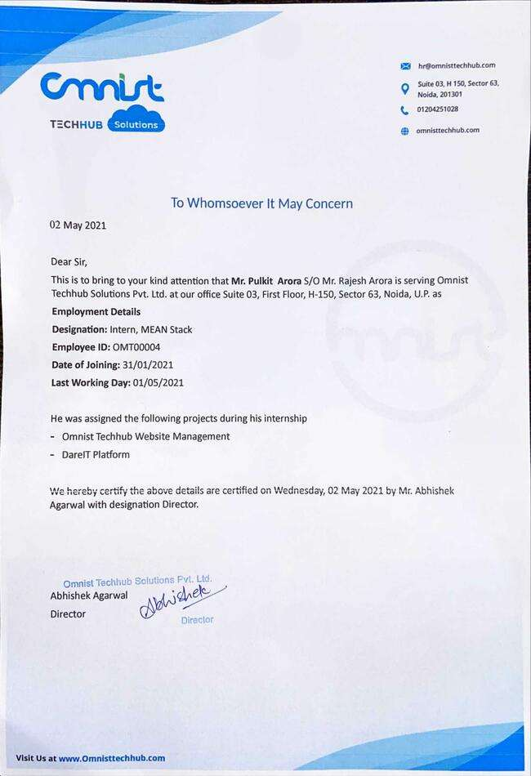
CERTIFICATE

Certified that Pulkit Arora (1900290149075) has carried out the project work presented in this report entitled “DareIT” for the award of Master of Computer Application from Dr. A.P.J. Abdul Kalam Technical University, Lucknow under my supervision. The report embodies results of original work, and studies are carried out by the student himself and the contents of the report do not form the basis for the award of any other degree to the candidate or to anybody else from this or any other University.

Mr. Ankit Verma External Examiner
Assistant Professor
Dept. of Computer Application
KIET Group of Institutions, Ghaziabad

Dr. Ajay Kumar Srivastava
Professor & Head
Department of Computer Application
KIET Group of Institutions, Ghaziabad

Date:

ABSTRACT

Not just another Social Media App but a social daring app. With DareIT create Dares & challenges with others and post daily progress & final results on the platform for other users to see and get motivated.

This application is very useful and easy to use to both the task receiver and to one who assigns the tasks. The user can update the status of their tasks as ‘complete’ or ‘incomplete’.

To use this application the user just needs to sign up into the app and you are ready to go. The admin can assign and remove dares to each user as per requirement. As it is very difficult to keep track of each student or employee manually, the application provides an easy and manageable way to keep record of every single person.

There is no need for any physical reporting to the Dare Master as they can watch your daily report in the application itself.

In today’s smart world every one of us is using a smartphone no matter which platform (Android, iOS, Windows). Each platform has many applications which made it popular in the present generation. In DareIT Individual users can create or participate with friends and public dares and challenges created for a predefined prize money and time.

ACKNOWLEDGEMENTS
Success in life is never attained single handedly. My deepest gratitude goes to my thesis supervisor, Mr. Ankit Verma for his guidance, help and encouragement throughout my project work. Their enlightening ideas, comments, and suggestions. Words are not enough to express my gratitude to Dr. Ajay Kumar Shrivastava, Professor and Head, Department of Computer Applications, for his insightful comments and administrative help at various occasions.
Fortunately, I have many understanding friends, who have helped me a lot in many critical conditions.
Finally, my sincere thanks go to my family members and all those who have directly and indirectly provided me moral support and other kinds of help. Without their support, completion of this work would not have been possible in time. They keep my life filled with enjoyment and happiness.

Pulkit Arora
(1900290149075)
LIST OF FIGURES

1.1 Gantt Chart | 5
2.1 Bazel Support | 7
2.2 Key parts of Angular 8 Architecture | 12
2.3 Features Of Angular | 15
2.4 Angular Market | 17
2.5.1 Visual Studio Home | 20
2.5.2 AngularFire | 25
2.5.3.1 NodeJS Download | 28
2.5.3.2 NodeJS Installation | 30
4.1 Process | 40
4.2 Dataflow | 40
4.3 Database/Data Warehouse | 41
4.4 Terminator | 42
4.5 Level 0 DFD | 42
4.6 Level 1 DFD | 43
5.1 Splash Screen | 44
5.2 Home Screen | 45
5.3 Login Screen | 46
5.4.1 Registration Screen | 47
5.4.2 Mobile Application Register Screen | 48
5.5 Dashboard | 49
5.6 Dare/ Challenges List | 50
5.7 Dare Creation | 51
5.8 Challenge Creation | 52
5.9 Dare/ Challenge Accept or Reject | 53
5.10 Landing Page Bar | 54
5.11 Vote Page | 55
5.12 User List | 55
5.13 User Profile | 56
5.14 DareIT Arena Dashboard | 58
6 Localhost:3000 | 60

CHAPTER 1
INTRODUCTION
1.1 PROJECT TITLE
- DareIT - The Last Man Standing
- An Application used to assign dares to friends or family to keep track of their work and health status.
- In this application, the controlling authority needs to get into the app by signing up as an admin and then they can assign tasks to every user registered on the application.
- Provide proper functionality in a very efficient manner so that users can easily use this application.
- Admin users consist of institutions like schools, colleges, Corporates, clubs etc. or Individuals who want to organize Dares for Public or a selected group of people.
- Users can also post other content on the platform like their daily activities by posting photos and videos on “The Wall”
- Users can upload daily updates and final claim proof on the platform for other participants and users to see and get motivated.
- This project is part of my training at my organisation.
1.2 PROJECT DESCRIPTION
The primary objective to develop this application Dareit – The Last Man Standing is to provide a solution in a next generation social media platform which serves as a common playground for like-minded people to challenge each other over dares & challenges and share their passion with the world.

Be a one stop platform for all the Challenges and Dares ever to be created anywhere in the universe and make Dareit a single point of connection for all passionate souls
Every member of the Dareit family to be at the top of all competitions and break & create new world records and create new history every hour. Sponsor every event which requires a proper platform to justify its objective. Sponsor & support the right talent to reach its potential. Lead creation of new tech to make earth a better place to live in again.

The basic purposes of the project are as follows:
- Time Saving
- Skill Generation
- Lead Creation
- Health Benefits
- Cost effective
- Reliable
- Easily Accessible
1.3 PROJECT SCOPE
The main objective of this project is to provide easy and good solutions for Admin users consisting of institutions like schools, colleges, Corporates, clubs etc or Individuals who wants to organize Dares for Public or a selected group of people & to assign daily dares to their students, friends, family or to their employees. This application provides a very easy and user-friendly user interface for everyone. The admin can check the status of the dares assigned to every individual. To use this application the controlling authority needs to register as admin in this application and others can register normally. The admin can assign dares to each registered user of the application and can check the report of them. There is no need for physical reporting to give a report or update the status of assigned work. This application provides all functionality at the fingertips of the user.

Admin users will act as an organizer instead of a participant. Admin users will have more options while creating the dare like creating only a participating dare instead of a competition.
Using the platform, users can either create a dare (where every participant has to compete with each other) or a challenge (where only the acceptor has to complete the given task).
The users put their share of dare/ challenge in the wallet which the winners can claim by submitting his proofs to other users after the target time.
1.4 HARDWARE/SOFTWARE USED IN PROJECT
Hardware and software are two necessities for development on this tool. The hardware and the software used in the application are as follows:
- Microsoft Windows 10
- RAM 4GB
- Minimum 30 GB hard disk Storage Space
- Laptop Machine
- Google Firebase
- Angular 8
- Php
- Database Design (MySQL)
- Reporting Tool (Data Report)

1.5 Goals of proposed system

1. Planned approach towards working: - The working in the organization will be well planned and organized. The data will be stored properly in data stores, which will help in retrieval of information as well as its storage.
2. Accuracy: - The level of accuracy in the proposed system will be higher. All operations would be done correctly and it ensures that whatever information is coming from the center is accurate.
3. Reliability: - The reliability of the proposed system will be high due to the above stated reasons. The reason for the increased reliability of the system is that now there would be proper storage of information.
4. No Redundancy: - In the proposed system utmost care would be that no information is repeated anywhere, in storage or otherwise. This would assure economic use of storage space and consistency in the data stored.
5. Immediate retrieval of information: - The main objective of the proposed system is to provide for a quick and efficient retrieval of information.
6. Immediate storage of information: - In manual systems there are many problems with storing the largest amount of information.
7. Easy to Operate: - The system should be easy to operate and should be such that it can be developed within a short period of time and fit in the limited budget of the user.

1.6 Project Requirements

Hardware Requirements (Processor RAM Disk Space)
Pentium II, Pentium III, Pentium IV, Higher 128 Mb or Higher 130 Mb

Software Requirements (Operating System Database)
Win-98, Win-XP, Linux, My SQL

1.7 User Characteristics
Every user should be:
- Comfortable with an Internet Browser.
- He must have brief knowledge of the dare system.
- He must also have basic knowledge of English too.

1.8 Constraints
- GUI is only in English.
- Login and password is used for identification of User & Admin.

1.9 PROJECT SCHEDULE (GANTT CHART)
The estimated period for this project was 6 months. The work was divided into several phases as shown in the Gantt chart. Firstly, we researched and got familiarized with the tool which we used during later phases. The design and planning of the software and hardware part followed. After that we started coding for this project and then testing and debugging were performed along the way. Hence, complete the project in time as expected.













GANTT CHART
3
2.5
2
1.5
1
0.5
0
Figure 1.1 Gantt Chart

CHAPTER 2
LITERATURE REVIEW
2.1 WHAT IS ANGULAR
Angular is a development platform, built on TypeScript. As a platform, Angular includes:

- A component-based framework for building scalable web applications
- A collection of well-integrated libraries that cover a wide variety of features, including routing, forms management, client-server communication, and more
- A suite of developer tools to help you develop, build, test, and update your code

With Angular, you're taking advantage of a platform that can scale from single-developer projects to enterprise-level applications. Angular is designed to make updating as straightforward as possible, so take advantage of the latest developments with a minimum of effort. Best of all, the Angular ecosystem consists of a diverse group of over 1.7 million developers, library authors, and content creators.

Angular applications: The essentials
This section explains the core ideas behind Angular. Understanding these ideas can help you design and build your applications more effectively.

Components
Components are the building blocks that compose an application. A component includes a TypeScript class with a @Component() decorator, an HTML template, and styles. The @Component() decorator specifies the following Angular-specific information:

A CSS selector that defines how the component is used in a template. HTML elements in your template that match this selector become instances of the component.
An HTML template that instructs Angular how to render the component.
An optional set of CSS styles that define the appearance of the template's HTML elements.
The following is a minimal Angular component.
import { Component } from '@angular/core';

@Component({
selector: 'hello-world',
template: `
<h2>Hello World</h2>
<p>This is my first component!</p>
`,
})
export class HelloWorldComponent {
// The code in this class drives the component's behavior.
}

Templates
Every component has an HTML template that declares how that component renders. You define this template either inline or by file path.
Angular extends HTML with additional syntax that lets you insert dynamic values from your component. Angular automatically updates the rendered DOM when your component’s state changes. One application of this feature is inserting dynamic text, as shown in the following example.
<p>{{ message }}</p>

Add additional functionality to your templates through the use of directives. The most popular directives in Angular are *ngIf and *ngFor. Use directives to perform a variety of tasks, such as dynamically modifying the DOM structure. And create your own custom directives to create great user experiences.
Angular's declarative templates let you cleanly separate your application's logic from its presentation. Templates are based on standard HTML, for ease in building, maintaining, and updating.

Dependency injection
Dependency injection lets you declare the dependencies of your TypeScript classes without taking care of their instantiation. Instead, Angular handles the instantiation for you. This design pattern lets you write more testable and flexible code. Even though understanding dependency injection is not critical to start using Angular, we strongly recommend it as a best practice and many aspects of Angular take advantage of it to some degree.
To illustrate how dependency injection works, consider the following example. The first file, logger.service.ts, defines a Logger class. This class contains a writeCount function that logs a number to the console.

Angular CLI
The Angular CLI is the fastest, straightforward, and recommended way to develop Angular applications. The Angular CLI makes a number of tasks trouble-free. Here are some examples:

ng build | Compiles an Angular app into an output directory.
ng serve | Builds and serves your application, rebuilding on file changes.
ng generate | Generates or modifies files based on a schematic.
ng test | Runs unit tests on a given project.
ng e2e | Builds and serves an Angular application, then runs end-to-end tests.
You'll find the Angular CLI a valuable tool for building out your applications.
For more information about the Angular CLI, see the CLI Reference section.
This topic is intended to give you a brief overview of what Angular is, the advantages it provides, and what to expect as you start to build your applications.

2.2 FEATURES OF ANGULAR 8

Angular 8 has been out a few months now, and includes a handful of useful new features developers are already putting to good use. Google’s popular client-side web framework continues to evolve, and the latest major release includes features that focus on performance, stability and tooling.

Here’s a list of the top 5 new features in the framework

1. Differential loading
Differential loading is a new feature that lets you use version 8 of the Angular CLI to create two different production bundles of your app. Attributes on the <script> tag in your index.html file let the browser request the most appropriate bundle; modern browsers will request a bundle that uses ES2015 JavaScript syntax and will be significantly smaller than the legacy bundle that uses ES5 syntax to maintain support for older browsers. Differential loading is enabled by default for new apps created with version 8 of the CLI, but you can easily enable this feature on your existing apps by upgrading to Angular 8, adding a browser list configuration file, and setting the “target” option in your tsconfig.json file to “es2015”. The result? Your users with modern browsers get a smaller bundle that loads faster (and puts a bigger smile on their face).

2. New lazy loading syntax
Lazy loading feature modules has been a best practice in Angular for quite a while. That hasn’t changed in version 8, but in place of the proprietary syntax to enable lazy loading, the framework has adopted the more common dynamic import syntax used widely in client-side web development. The new syntax relies less on parsing class names from strings and enables editors and IDEs to check that you’re importing the correct items.

3. Create web workers with the CLI
Angular 8 makes it easier than ever to use web workers to handle CPU-intensive tasks in your apps. Version 8 of the Angular CLI includes a new schematic used with the ng generate command to create and update the necessary files in your project to add a new web worker. The new and updated files include a basic template for your new web worker so you can worry less about boilerplate syntax and more quickly focus on writing the code you want to run on a background thread.

4. Builder and workspace APIs
Although they’re probably not a feature you’ll use on every project, Angular 8 also includes new APIs that allow you to create custom build and deployment commands using hooks into the familiar ng build, ng test, and ng run commands. There are also new APIs that allow you to open and work with the workspace defined in your angular.json file, which should reduce the amount of manual manipulation required to perfectly configure your project.

5. A new guide for old features
The Angular team included a new deprecation guide with Angular 8 to make it easier for developers to keep track of deprecated features and APIs. The creation of this guide should not be misinterpreted as a warning that deprecations will be sprung on the developer community with little time for remediation. In fact, the Angular team is committed to supporting features for two major releases after officially being deprecated. The resulting stability in the framework coupled with the helpful deprecation guide should smooth the transition away from those older features.

- Storage - SQLite, a lightweight relational database, for data storage. Chapter discusses data storage in more detail
- Connectivity - GSM/EDGE, IDEN, CDMA, EV-DO, UMTS, Bluetooth (includes A2DP and AVRCP), Wi-Fi, LTE and WIMAX
- Media support - H.263, H.264 (in 3GP or MP4 container), MPEG-4 SP, AMR, AMR-WB (in 3GP container), AAC, HE-AAC (in or 3GP container), MP3, MIDI, Ogg Vorbis, WAV, JPEG, PNG, GIF, and BMP.
- Hardware support - Accelerometer sensor, camera, digital compass, proximity sensor, and GPS.
- Multi-touch - Multi-touch screens.
- Multi-tasking - Multi-tasking applications.
- Tethering - Sharing of Internet connections as a wired/wireless hotspot

Preview of Ivy
If you have been following Angular then you probably encountered the word “Ivy”. Ivy is a major change in Angular history, it an angular renderer which is radically different from anything as it uses incremental DOM. It changes how the framework internally works, without changing our Angular applications. The Ivy project is basically rewriting the Angular compiler and runtime code in order to reach
- better build times ( incremental approach)
- better build sizes more compatible with tree-shaking
- new potential features like lazy loading of component instead of modules

Bazel Support
One of the new features of Angular 8 is the possibility to build your CLI application with Bazel. The Angular framework itself is built with Bazel.

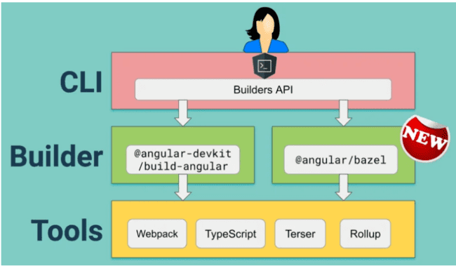
Figure 2.1 Bazel Support

2.3 ARCHITECTURE OF ANGULAR 8
Angular 8 is a platform and a framework which is used to build client applications in HTML and TypeScript.

Angular 8 is written in TypeScript. It implements core and optional functionality as a set of TypeScript libraries that you can import into your apps.
The basic building blocks of an Angular application are NgModules, which provide a compilation context for components. NgModules collect related code into functional sets; an Angular app is defined by a set of NgModules. An app always has at least a root module that enables bootstrapping, and typically has many more feature modules.
- Components define views, which are sets of screen elements that Angular can choose among and modify according to your program logic and data.
- Components use services, which provide specific functionality not directly related to views. Service providers can be injected into components as dependencies, making your code modular, reusable, and efficient.

Angular 8 Components
In Angular 8, Components and services both are simply classes with decorators that mark their types and provide metadata which guide Angular to do things.
Every Angular application always has at least one component known as root component that connects a page hierarchy with page DOM. Each component defines a class that contains application data and logic, and is associated with an HTML template that defines a view to be displayed in a target environment.
Metadata of Component class
- The metadata for a component class associates it with a template that defines a view. A template combines ordinary HTML with Angular directives and binding markup that allow Angular to modify the HTML before rendering it for display.
- The metadata for a service class provides the information Angular needs to make it available to components through dependency injection (DI).

Modules
Angular 8 NgModules are different from other JavaScript modules. Every Angular 8 app has a root module known as AppModule. It provides the bootstrap mechanism that launches the application.
Generally, every Angular 8 app contains many functional modules.
Some important features of Anngular 8 Modules:
- Angular 8 NgModules import the functionalities form other NgModules just like other JavaScript modules.
- NgModules allow their own functionality to be exported and used by other NgModules. For example, if you want to use the router service in your app, you can import the Router NgModule.

Template, Directives and Data Binding
In Angular 8, a template is used to combine HTML with Angular Markup and modify HTML elements before displaying them. Template directives provide program logic, and binding markup connects your application data and the DOM.
There are two types of data binding:
1. Event Binding: Event binding is used to bind events to your app and respond to user input in the target environment by updating your application data.
2. Property Binding: Property binding is used to pass data from component class and facilitates you to interpolate values that are computed from your application data into the HTML.

Services and Dependency Injection
In Angular 8, developers create a service class for data or logic that isn't associated with a specific view, and they want to share across components.
Dependency Injection (DI) is used to make your component classes lean and efficient. DI doesn't fetch data from the server, validate user input, or log directly to the console; it simply renders such tasks to services.

Routing3
In Angular 8, Router is an NgModule which provides a service that facilitates developers to define a navigation path among the different application states and view hierarchies in their app.
It works in the same way as a browser's navigation works. i.e.:
- Enter a URL in the address bar and the browser will navigate to that corresponding page.
- Click the link on a page and the browser will navigate to a new page.
- Click the browser's back or forward buttons and the browser will navigate backward or forward according to your seen history pages.

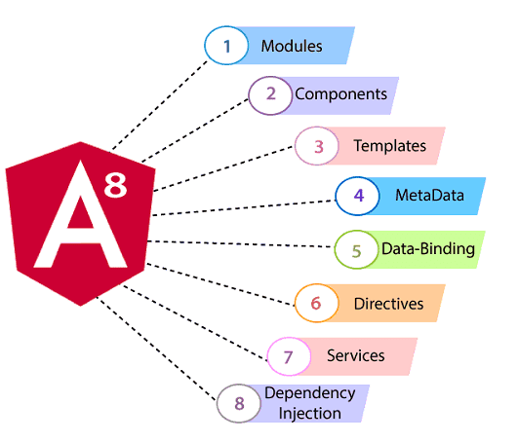

Figure 2.2 Key parts of Angular 8 Architecture
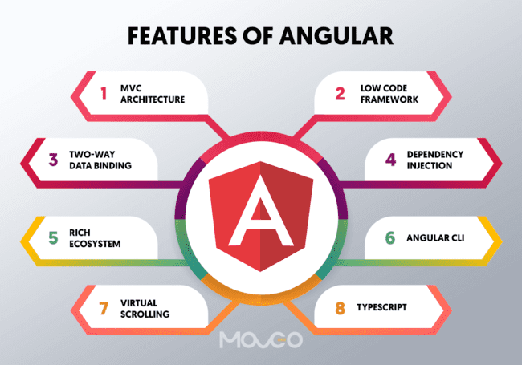
Figure 2.3 Features Of Angular

2.4 THE ANGULAR MARKET
Angular is a framework and a platform used for building SPA – Single Page Applications. It uses TypeScript and HTML. Angular is one of the most mature frameworks with good support and backing of an efficient and big team of contributors. It can be considered a full-stack package solution. But with full-stack-solutions comes full-stack learning, and that can be a little overwhelming at times. The learning curve with Angular can be steep that might put new developers off.

Journey of Angular
AngularJS was launched as an open-source project by Misko Hevery and others at Google in 2010. AngularJS enjoyed its popularity till 2014-15. However, it started failing to meet the demands of the time by then. In response to this Google scratched out AngularJS entirely and launched Angular 2 which is also known as Angular now. This decision met with a few consequences during 2016 as many developers started shifting to other frameworks like React because of the sudden change announced by Angular. By 2017-18 Angular regained their market share and came back stronger than before.
Here are the last 5 years NPM trends for Angular.
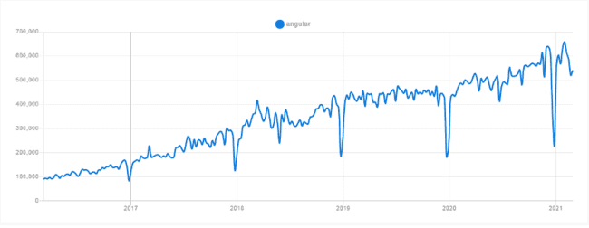
Figure 2.4 Angular Market

Prerequisites for using Angular
- HTML
- JavaScript
- TypeScript

Angular Framework Terminologies to get familiar with
- Components – These are the very basic UI building block on Angular applications. Each component in Angular consists of –
  - An HTML template for declaring what renders on the page
  - A TypeScript class for defining behavior
  - A CSS sector to define how the component is going to be used in a template
- Services- A service is an object or a function available for and exclusive to an AngularJS application.
- Modules – Modules are a mechanism that helps group the related components, pipes, directives, and services to be combined with other modules to create an app. Modules can be considered as puzzle pieces of an Angular app.

Pros & Cons of Angular
Pros
- Follows clean code development.
- Has a material-design like interface.
- Updates can be seamless using Angular CLI.
- It is a high performing full-stack framework.
Cons
- Angular features can be confusing for beginners.
- Lacks all-inclusive documentation.
- Need to learn Typescript and other framework specific components.
- Though it is a full stack solution, third party integrations can be complicated.
- Switching between versions can be troublesome.

Where to Use Angular
- You want a ready-to-use full stack solution.
- You want a scalable feature-rich application.
- When you are looking for performance oriented web solutions.

Popular Web App based on Angular framework
- Forbes
- Google Voice
- Google Messages
- Samsung Forward
- Google Play Books
- Microsoft Office Home

2.5 OBTAINING THE REQUIRED TOOLS
Learn one way to build applications with Angular and reuse your code and abilities to build apps for any deployment target. For web, mobile web, native mobile and native desktop.
2.5.1 Visual Studio
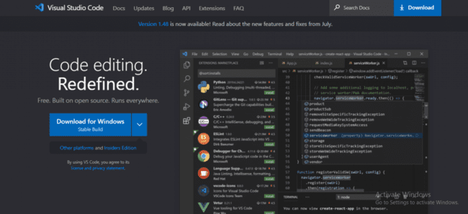

Figure 2.5.1 Visual Studio Home
Visual Studio Code has been specially created by Microsoft for Windows, macOS, and Linux. It comes with an intelligent editor, making it one of the fastest AngularJS development tools available today.
Features
- Its IntelliSense feature offers smart completions of imported modules, variable types, and even function definitions.
- Built-in GUI for Git provides ease of seeing the changes made in the project.
- Peek Function expands into an inline window displaying the full definition of the function.
Pricing: Completely free and built on open source.
Pros
- Multiple OS Support – Runs on Windows, macOS, and Linux
- For private and commercial use the tool is very useful.
- Proactive support for required plugins
- Open-source platform – can be easily downloaded and updated
Cons
- Debugging process is not as efficient as other development tools.

2.5.2 AngularFire
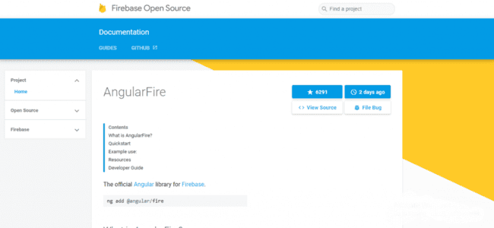

Figure 2.5.2 AngularFire

Angular Fire is a backend development tool that facilitates dynamic API features, 3-way data binding, and superior development capacity.
Features
- Stores data automatically for offline use
- Offers synchronized real-time binding
- Easily manage binary data files like images, videos, and blobs
- It is officially supported by AngularJS binding for Firebase
Pricing: Open Source
Pros
- Provides flexible and dynamic API
- Offers real-time data synchronization
- Superior developer experience
Cons
- Ordinary documentation features

2.5.3 Browser support
Angular supports most recent browsers. This includes the following specific versions:

Browser | Supported versions
Chrome | latest
Firefox | latest and extended support release (ESR)
Edge | 2 most recent major versions
IE | 11  *deprecated, see the deprecations guide
Safari | 2 most recent major versions
iOS | 2 most recent major versions
Android | Q (10.0), Pie (9.0), Oreo (8.0), Nougat (7.0)

Angular 8 Installation
(How to install Angular 8 or Angular 8 Environment setup)
Before to setup environment for Angular development using the Angular CLI tool, you must have installed Node.js on your system and set a development environment and npm package manager.

Install Node.js
Angular requires Node.js version 10.9.0 or later. You can download it from https://nodejs.org/en/
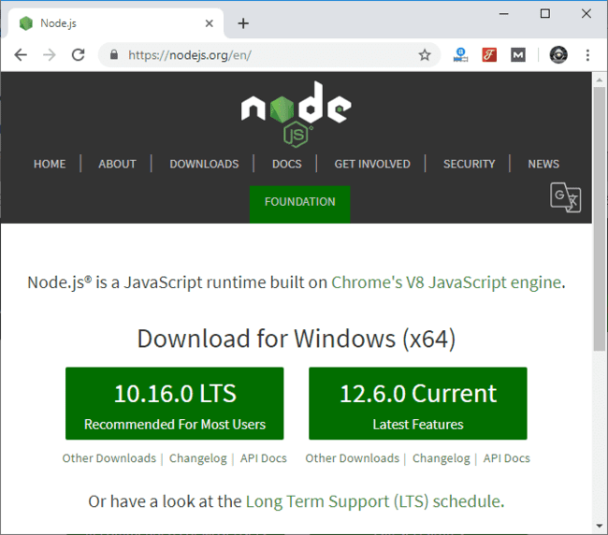
Figure 2.5.3.1 NodeJS Download

After downloading, you have to install it on your system.
26.1K
1/4 NgRx Introduction and setup with lazy loaded modules [2020]
Next
Stay
See how to install Node.js on Windows:
See how to install Node.js on Linux/ Ubuntu/ CentOS:
Once you have installed Node.js on your system, open node.js command prompt.
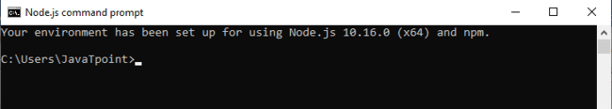
- To check your version, run node -v in a terminal/console window.
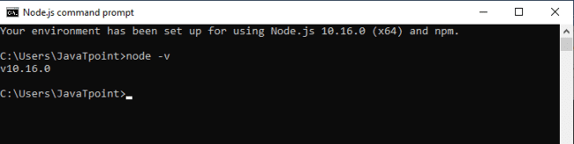
Figure 2.5.3.2 NodeJS Installation

Use npm to Install Angular CLI
Use the following command to install Angular CLI
- npm install -g @angular/cli
Or
- npm install -g @angular/cli@latest

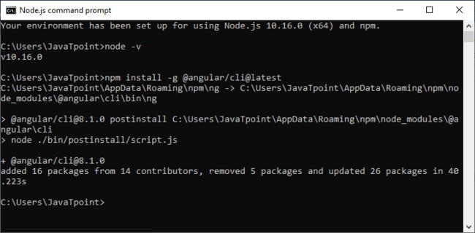
Or
Just go to Angular CLI official website https://cli.angular.io/
You will see the whole cli command to create an Angular app. You need to run the first command to install Angular CLI. These steps are same for Windows and Mac.

Setting up the local environment and workspace

This guide explains how to set up your environment for Angular development using the Angular CLI tool. It includes information about prerequisites, installing the CLI, creating an initial workspace and starter app, and running that app locally to verify your setup.

If you are new to Angular, you might want to start with Try it now!, which introduces the essentials of Angular in the context of a ready-made basic online store app for you to examine and modify. This standalone tutorial takes advantage of the interactive StackBlitz environment for online development. You don't need to set up your local environment until you're ready.

Prerequisites
To use the Angular framework, you should be familiar with the following:
JavaScript
HTML
CSS
Knowledge of TypeScript is helpful, but not required.

To install Angular on your local system, you need the following:

Node.js
Angular requires an active LTS or maintenance LTS version of Node.js.
For information about specific version requirements, see the engines key in the package.json file.
For more information on installing Node.js, see nodejs.org. If you are unsure what version of Node.js runs on your system, run node -v in a terminal window.
npm package manager

Angular, the Angular CLI, and Angular applications depend on npm packages for many features and functions. To download and install npm packages, you need an npm package manager. This guide uses the npm client command line interface, which is installed with Node.js by default. To check that you have the npm client installed, run npm -v in a terminal window.
Install the Angular CLI
You use the Angular CLI to create projects, generate application and library code, and perform a variety of ongoing development tasks such as testing, bundling, and deployment.
To install the Angular CLI, open a terminal window and run the following command:
content_copy
npm install -g @angular/cli
Create a workspace and initial application
You develop apps in the context of an Angular workspace.
To create a new workspace and initial starter app:
Run the CLI command ng new and provide the name my-app, as shown here:

content_copy
ng new my-app

The ng new command prompts you for information about features to include in the initial app. Accept the defaults by pressing the Enter or Return key.
The Angular CLI installs the necessary Angular npm packages and other dependencies. This can take a few minutes.
The CLI creates a new workspace and a simple Welcome app, ready to run.
Run the application
The Angular CLI includes a server, for you to build and serve your app locally.
Navigate to the workspace folder, such as my-app.
Run the following command:

content_copy
cd my-app
ng serve --open

The ng serve command launches the server, watches your files, and rebuilds the app as you make changes to those files.

The --open (or just -o) option automatically opens your browser to http://localhost:4200/.
If your installation and setup was successful, you should see a page similar to the following.

Angular is a front-end framework which is used to create web applications. It uses typescript by default for creating logics and methods for a class but the browser doesn’t know typescript. Here webpack comes in picture, webpack is used to compile these typescript files to JavaScript. In addition, there are so many configuration files you will need to run an angular project on your computer.
Angular CLI is a tool that does all these things for you in some simple commands. Angular CLI uses webpack behind to do all this process.

Note: Please make sure you have installed node and npm in your system. You can check your node version and npm version by using the following command:

node --version
npm --version

Steps to Create your first application using angular CLI:

Step-1: Install angular cli
npm install - g @angular/cli

Step-2: Create new project by this command
Choose yes for the routing option, CSS or SCSS.

ng new myNewApp

Step-3: Go to your project directory
cd myNewApp

Step-4: Run server and see your application in action
ng serve -o --poll=2000

Introduction to directory structure:

e2e - It contains code related to automated testing purposes. For example, if on a certain page you are calling a REST API then what should be the return status code, whether it is acceptable or not etc.
node_modules: It saves all the dev dependencies (used only at development time) and dependencies (used for development as well as needed in production time), any new dependency when added to the project it is automatically saved to this folder.
src This directory contains all of our work related to project i.e. creating components, creating services, adding CSS to the respective page, etc.
package.json This file stores the information about the libraries added and used in the project with their specified version installed. Whenever a new library is added to the project its name and version is added to the dependencies in package.json.

Other files: As a beginner you don’t need these files at this time, don’t bother about that. These all are used for editor configurations and information needed at compile time. The builtin webpack in angular CLI manages all for you.

Inside src folder:

index.html This is the entry point for the application, app-root tag is the entry point of the application on this single page application, on this page angular will add or remove the content from the DOM or will add new content to the DOM. Base href=”/” is important for routing purposes.

<!DOCTYPE HTML>
<html lang="en">
<head>
<meta charset="utf-8">
<title>MyNewApp</title>
<base href="/">

<meta name="viewport" content="width=device-width, initial-scale=1">
<link rel="icon" typw="image/x-icon" href="favison.ico">
</head>
<body>
<app-root></app-root>
</body>
</html>

style.scss - This file is the global stylesheet where you can add CSS classes or selectors which are common to many components, for example, you can import custom fonts, import bootstrap.css, etc.
assets It contains the js images, fonts, icons and many other files for your project.
Inside app folder:

app.module.ts An angular project is a composite of so many other modules in order to create an application you have to create a root module for your application in the hierarchy. This app.module.ts file is that. If you want to add more modules at the root level, you can add.
declarations It is the reference of the array to store its components. The app component is the default component that is generated when a project is created. You have to add all your component’s references to this array to make them available in the project.
imports If you want to add any module whether angular or you have to add it to imports array to make them available in the whole project.
providers If you will create any service for your application then you will inject it into your project through this provider array. Service injected to a module is available to it and it’s child module in the project hierarchy.

Bootstrap - This has reference to the default component created, i.e., AppComponent
app.component.html Edit this file to make changes to the page. You can edit this file as an HTML file. Work directly with div or any other tag used inside body tags, these are components and do not add html head body tags.

<h1>
Hello world
</h1>

<div>
<p>
This is my First Angular app.
</p>
</div>

app.component.spec.ts -These are automatically generated files which contain unit tests for source components.

app.component.ts -You can do the processing of the HTML structure in the .ts file. The processing will include activities such as connecting to the database, interacting with other components, routing, services, etc.
app.component.scss -Here you can add CSS for your component. You can write scss which is further compiled to CSS by a transpiler.

More commands that you will need while working on the project:

- ng generate component component_name
- ng generate service service_name
- ng generate directive directive_name

2.5.4 CREATING NEW PROJECT
Create a new project
You begin by creating an initial application using the Angular CLI. Throughout this tutorial, you’ll modify and extend that starter application to create the Tour of Heroes application.
In this part of the tutorial, you'll do the following:
- Set up your environment.
- Create a new workspace and initial application project.
- Serve the application.
- Make changes to the application.

Set up your environment
To set up your development environment, follow the instructions in Local Environment Setup.

Create a new workspace and an initial application
You develop applications in the context of an Angular workspace. A workspace contains the files for one or more projects. A project is the set of files that comprise an application or a library. For this tutorial, you will create a new workspace.
To create a new workspace and an initial application project:
- Ensure that you are not already in an Angular workspace folder. For example, if you have previously created the Getting Started workspace, change to the parent of that folder.
- Run the CLI command ng new and provide the name angular-tour-of-heroes, as shown here:
- content_copy
- ng new angular-tour-of-heroes
- The ng new command prompts you for information about features to include in the initial application project. Accept the defaults by pressing the Enter or Return key.
The Angular CLI installs the necessary Angular npm packages and other dependencies. This can take a few minutes.
It also creates the following workspace and starter project files:
- A new workspace, with a root folder named angular-tour-of-heroes.
- An initial skeleton app project in the src/app subfolder.
- Related configuration files.
The initial app project contains a simple Welcome application, ready to run.

Serve the application
Go to the workspace directory and launch the application.
content_copy
cd angular-tour-of-heroes
ng serve --open
The ng serve command builds the app, starts the development server, watches the source files, and rebuilds the application as you make changes to those files.
The --open flag opens a browser to http://localhost:4200/.
You should see the application running in your browser.

Angular components
The page you see is the application shell. The shell is controlled by an Angular component named AppComponent.
Components are the fundamental building blocks of Angular applications. They display data on the screen, listen for user input, and take action based on that input.

Make changes to the application
Open the project in your favorite editor or IDE and navigate to the src/app folder to make some changes to the starter application.
You'll find the implementation of the shell AppComponent distributed over three files:
- app.component.ts— the component class code, written in TypeScript.
- app.component.html— the component template, written in HTML.
- app.component.css— the component's private CSS styles.

Change the application title
Open the component class file (app.component.ts) and change the value of the title property to 'Tour of Heroes'.
app.component.ts (class title property)
content_copy
title = 'Tour of Heroes';
Open the component template file (app.component.html) and delete the default template generated by the Angular CLI. Replace it with the following line of HTML.
app.component.html (template)
content_copy
<h1>{{title}}</h1>
The double curly braces are Angular's interpolation binding syntax. This interpolation binding presents the component's title property value inside the HTML header tag.
The browser refreshes and displays the new application title.

Add application styles
Most apps strive for a consistent look across the application. The CLI generated an empty styles.css for this purpose. Put your application-wide styles there.
Open src/styles.css and add the code below to the file.
src/styles.css (excerpt)
content_copy
/* Application-wide Styles */
h1 {
color: #369;
font-family: Arial, Helvetica, sans-serif;
font-size: 250%;
}
h2, h3 {
color: #444;
font-family: Arial, Helvetica, sans-serif;
font-weight: lighter;
}
body {
margin: 2em;
}
body, input[type="text"], button {
color: #333;
font-family: Cambria, Georgia, serif;
}
/* everywhere else */
* {
font-family: Arial, Helvetica, sans-serif;
}

Final code review
Here are the code files discussed on this page.
src/app/app.component.tssrc/app/app.component.htmlsrc/styles.css (excerpt)
content_copy
import { Component } from '@angular/core';

@Component({
selector: 'app-root',
templateUrl: './app.component.html',
styleUrls: ['./app.component.css']
})
export class AppComponent {
title = 'Tour of Heroes';
}

Summary
- You created the initial application structure using the Angular CLI.
- You learned that Angular components display data.
- You used the double curly braces of interpolation to display the application title.

2.6 OPERATING SYSTEM FOR ANGULAR 8 DEVELOPMENT
This is probably the one topic you don’t have to worry about. Either you can pick the operating system on your computer used for development, or it is limited by the IT-policies of your employer. For most Angular developers, any of the officially supported operating system works fine. However, there are situations where the choice will matter.
Angular 8 supports TypeScript 3.4 and it is required to run your Angular 8 project. So you have to upgrade your TypeScript version to 3.4

CHAPTER 3
TECHNICAL FEASIBILITY
3.1 FEASIBILITY STUDY
Feasibility is a measure of how beneficial the development of the information system will be to an organization. This is done by investigating the existing system in the area under investigation or general ideas about a new system. It is a test of a system proposal according to its workability, impact on the organization, ability to meet user needs and effective use of resources.
A prefeasibility study seeks to validate a project and to expose organizational spots or problems that may condemn it before it sees the light of day, using a limited number of analytical tools. A prefeasibility study does not concentrate on the day-to-day operations; in other words, it does not investigate the specifics of tasks or the team member composition. This is something that the feasibility study does. From this perspective, a feasibility study is very pragmatic; once we have defined the project in approximate terms using the five frames of analysis, we can then examine how this is going to translate into daily operations, most evident during the transformation phase.

Depending on the results of the initial investigation the survey is now expanded to a more detailed feasibility study. “FEASIBILITY STUDY” is a test of system proposal according to its workability, impact of the organization, ability to meet needs and effective use of the resources. It focuses on these major questions:
1. What are the user’s demonstrable needs and how does a candidate system meet them?
2. What resources are available for a given candidate system?
3. What are the likely impacts of the candidate system on the organization?
4. Is it worth solving the problem?

During feasibility analysis for this project, following primary areas of interest are to be considered. Investigation and generating ideas about a new system does this.
Steps in feasibility analysis
Eight steps involved in the feasibility analysis are:

- Form a project team and appoint a project leader.
- Prepare system flowcharts.
- Enumerate potential proposed systems.
- Define and identify characteristics of the proposed system.
- Determine and evaluate performance and cost effective of each proposed system.
- Weight system performance and cost data.
- Select the best-proposed system.
- Prepare and report the final project directive to management.

3.2 TECHNICAL FEASIBILITY
In examining the Technical feasibility of the system, more importance is given to the hardware interaction part of the system. The assessments of technical feasibility center on the existing system and to what extent it can support the proposed addition. This was based on an outline design of system requirements in turns of inputs, files, programs, procedures, and staff. It involves financial considerations to accommodate technical enhancements.
In this project, the technical team can convert their ideas into a working model which shows that the project is TECHNICAL FEASIBLE. The hardware and software used in the project are easily available and easily used. The project is very easy to use by different users which also prove that the project is TECHNICALLY FEASIBLE.

A study of resource availability that may affect the ability to achieve an acceptable system. This evaluation determines whether the technology needed for the proposed system is available or not.
- Can the work for the project be done with current equipment, existing software technology & available personnel?
- Can the system be upgraded if developed?
- If new technology is needed then what can be developed?
- This is concerned with specifying equipment and software that will successfully satisfy the user requirement. The technical needs of the system may include:

Front-end and back-end selection
An important issue for the development of a project is the selection of suitable front-end and back-end. When we decided to develop the project we went through an extensive study to determine the most suitable platform that suits the needs of the organization as well as helps in development of the project.
The aspects of our study included the following factors.

Front-end selection:
1. It must have a GUI that assists employees that are not from IT background.
2. Scalability and extensibility.
3. Flexibility.
4. Robustness.
5. According to the organization requirement and the culture.
6. Must provide excellent reporting features with good printing support.
7. Platform independent.
8. Easy to debug and maintain.
9. Event driven programming facility.
10. Front end must support some popular back end like Ms Access.

According to the above stated features we selected Angular 8 as the front-end for
developing our project.

Back-end Selection:
1. Multiple user support.
2. Efficient data handling.
3. Provide inherent features for security.
4. Efficient data retrieval and maintenance.
5. Stored procedures.
6. Popularity.
7. Operating System compatible.
8. Easy to install.
9. Various drivers must be available.
10. Easy to implant with the Front-end.

According to the above stated features we selected MySQL as the backend.

Technical feasibility is frequently the most difficult area encountered at this stage. It is essential that the process of analysis and definition be conducted in parallel with an assessment to technical feasibility. It centers on the existing computer system and to what extent it can support the proposed system.

3.3 Economical feasibility

Economic justification is generally the “Bottom Line” consideration for most systems. Economic justification includes a broad range of concerns that includes cost benefit analysis. In this we weigh the cost and the benefits associated with the candidate system and if it suits the basic purpose of the organization i.e. profit making, the project is made to the analysis and design phase.
The financial and the economic questions during the preliminary investigation are
verified to estimate the following:
- The cost to conduct a full system investigation.
- The cost of hardware and software for the class of application being considered.
- The benefits in the form of reduced cost.
- The proposed system will give the minute information, as a result the
performance is improved
- This feasibility checks whether the system can be developed with the available funds. The DareIT does not require an enormous amount of money to be developed. This can be done economically if planned judicially, so it is economically feasible. The cost of the project depends upon the number of man-hours required.

3.4 Operational Feasibility

It is mainly related to human organizations and political aspects. The points to be
considered are:
- What changes will be brought with the system?
- What organization structures are disturbed?
- What new skills will be required? Do the existing staff members have these
skills? If not, can they be trained in due course of time?
The system is operationally feasible as it is very easy for the End users to operate it. It only needs basic information about the Windows/Linux platform.

3.5 Schedule feasibility
Time evaluation is the most important consideration in the development of a project. The time schedule required for the development of this project is very important since more development time affects machine time, cost and causes delay in the development of other systems.
A reliable DareIT application can be developed in a considerable amount of time.

3.6 TECHNOLOGY DESCRIPTION
Technology is the collection of techniques, skills, methods, and processes used in the production of goods or services or in the production of goods or services in the accomplishment of objectives, such as scientific investigation. Technology can be the knowledge of techniques, processes, etc., or it can be embedded in machines, computers, devices, and factories which can operate by individuals without detailed knowledge of working on such things.
Technology can be defined as following ways:
- Tangible: blueprints, models, operating manuals, prototypes.
- Intangible: consultancy, problem-solving and training methods.
- High: entirely or almost entirely automated and intelligent technology that manipulates ever finer matter and ever powerful forces.
- Intermediate: semi-automated partially intelligent technology that manipulates refined matter and medium level forces.
- Low: labor intensive technology that manipulates only coarse or gross matter and weaker forces.
3.7 TECHNOLOGY USED IN THE PROJECT
3.7.1 ANGULAR
Angular is an application design framework and development platform for creating efficient and sophisticated single-page apps.
Angular is used as the frontend of the MEAN stack, consisting of MongoDB database, Express.js web application server framework, Angular itself (or AngularJS), and Node.js server runtime environment.
Angular 8 was released on May 28, 2019. Featuring Differential loading for all application code, Dynamic imports for lazy routes, Web workers, TypeScript 3.4 support, and Angular Ivy as an opt-in preview. Angular Ivy opt-in preview includes
- Generated code that is easier to read and debug at runtime
- Faster rebuild time
- Improved payload size
- Improved template type checking
- Backwards compatibility

3.7.1.1 FEATURES OF ANGULAR
- Fast Development
- Expressive and Flexible UI
- Native Performance
3.6.1.2 FAST DEVELOPMENT
Paint your app to life in milliseconds with Stateful Hot Reload. Use a rich set of fully customizable widgets to build native interfaces in minutes.
Angular hot reload helps you quickly and easily experiment, build UIs, add features, and fix bugs faster. Experience sub-second reload times without losing state on emulators, simulators, and hardware.
3.7.1.3 EXPRESSIVE AND FLEXIBLE UI
Quickly ship features with a focus on native end-user experiences. Layered architecture allows for full customization, which results in incredibly fast rendering and expressive and flexible designs.
Delight your users with Angular built-in beautiful Material Design and Cupertino (iOS-flavor) widgets, rich motion APIs, smooth natural scrolling, and platform awareness.
3.7.1.4 NATIVE PERFORMANCE
Angular widgets incorporate all critical platform differences such as scrolling, navigation, icons and fonts, and your Angular code is compiled to native ARM machine code using Dart’s native compilers.

3.7.1.5 CATEGORIES OF ANGULAR APPLICATION
- Mobile
- Web
- Desktop
3.7.1.6 ENVIRONMENT SETUP
To install and run Angular, your development environment must meet these minimum requirements:
- Operating Systems: Windows 7 SP1 or later (64-bit)
- Disk Space: 400 MB (does not include disk space for IDE/tools).
- Tools: Angular depends on these tools being available in your environment.
  - Bazel is a build tool developed and massively used by Google, as it can build pretty much any language. The Angular framework itself is built with Bazel.
If Git for Windows is already installed, make sure you can run git commands from the command prompt or PowerShell.

CHAPTER 4
BACKEND DESIGN
4.1 DATA FLOW DIAGRAM
A data flow diagram (DFD) is a graphical representation of the “flow” of data through an information system, modelling its process aspects. A DFD is often used as a preliminary stem to create an overview of the system, which can later be elaborated. DFDs can also use for the visualisation of data processing (Structure Design).
A DFD shows what kind of information will be input to and output from the system, where the data will come from and go to, and where the data will be stored. It does not show information about the timing of process or information about whether processes will operate in sequence or in parallel (which is shown on a flow chart).
Data flow diagram can be used in both Analysis and Design phase of the System Development Life Cycle (SDLC).
4.1.1 DFD COMPONENTS
DFD consists of processes, flows, warehouses, and terminators. There are several ways to view these DFD components.
4.1.1.1 PROCESS
The process (function, transformation) is part of a system that transforms inputs to outputs. The symbol of a process is a circle, an oval, a rectangle, or a rectangle with rounded corners (according to the type of notation). The process is named in one word, a short sentence, or a phrase that is clearly to express its essence.

Figure 4.1 Process
4.1.1.2 DATA FLOW
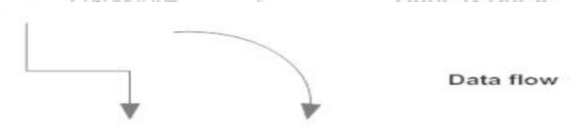
Data flow (flow, dataflow) shows the transfer of information (sometimes also material) from one part of the system to another. The symbol of the flow is the arrow. The flow should have a name that determines what information (or what material) is being moved. Exceptions are flows where it is clear what information is transferred through the entities that are linked to these flows. Material shifts are modelled in systems that are not merely informative. Flow should only transmit one type of information (material). The arrow shows the flow direction (it can also be bi-directional if the information to/from the entity is logically dependent - e.g. question and answer). Flows link processes, warehouses, and terminators.
Figure 4.2 Dataflow
4.1.1.3 WAREHOUSE
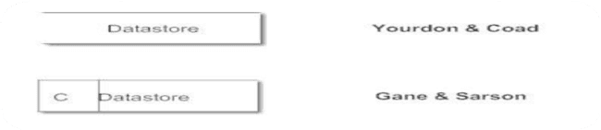
The warehouse (datastore, data store, file, database) is used to store data for later use. The symbol of the store is two horizontal lines, the other way of view is shown in the DFD Notation. The name of the warehouse is a plural noun (e.g. orders) - it derives from the input and output streams of the warehouse. The warehouse does not have to be just a data file, for example, a folder with documents, a filing cabinet, and optical discs. Therefore, viewing the warehouse in DFD is independent of implementation. The flow from the warehouse usually represents the reading of the data stored in the warehouse, and the flow to the warehouse usually expresses data entry or updating (sometimes also deleting data). Warehouse is represented by two parallel lines between which the memory name is located (it can be modelled as a UML buffer node).
Figure 4.3 Database/Data Warehouse
4.1.1.4 TERMINATOR
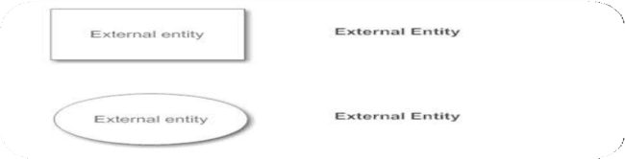
The Terminator is an external entity that communicates with the system and stands outside of the system. It can be, for example, various organizations (e.g. a bank), groups of people (e.g. customers), authorities (e.g. a tax office) or a department (e.g. a human-resources department) of the same organization, which does not belong to the model system. The terminator may be another system with which the modelled system communicates.
Figure 4.4 Terminator (External Entity)
4.2 DFD OF THE PROJECT
This project contains 0 (Context level) level and 1 level DFD.
4.2.1 LEVEL 0 DFD
A context diagram is a top level (also known as "Level 0") data flow diagram. It only contains one process node ("Process 0") that generalizes the function of the entire system in relation to external entities.
This level simply shows the admin who ultimately has complete access to the application in square box and complete application in circle.
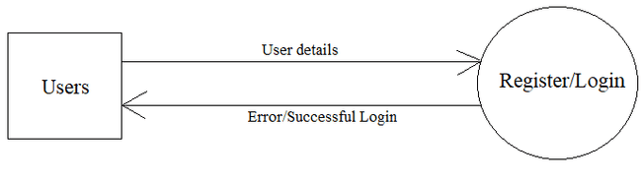
Figure 4.5 Level 0 DFD
4.2.2 LEVEL 1 DFD
The level 1 DFD shows how the system is divided into sub-system (processes), each of which deals with one or more of the data flows to or from an external agent, and which together provide all of the functionality of the system as a whole. This level will show all the processes and databases used in the application and the flow data between various processes.
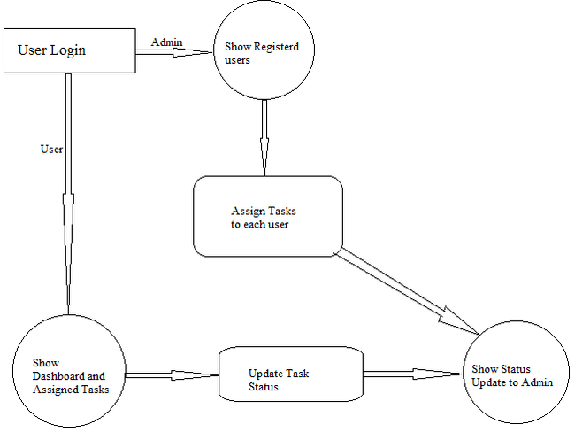
Figure 4.6 Level 1 DFD

CHAPTER 5
FRONTEND DESIGN
5.1 SPLASH SCREEN
This first screen of the application shows when a user opens an application which displays the logo and name of the application for a very short period. In this screen, we are providing a very effective animation.

Figure 5.1 Splash Screen
5.2 HOME SCREEN



Figure 5.2 Home Screen
Dareit – The Last Man Standing is a next generation social media platform which serves as a common playground for like-minded people to challenge each other over dares & challenges and share their passion with the world.

Website: Visit www.dareit.co
Android Application: Download from Play store “Dareit” or enter mobile number on www.dareit.co to download apk file

5.3 LOGIN SCREEN
Login screen provides the facility to access the application with valid username and password details. For Login User must enter User Id and Password for Login and click Login button. Only authorized person can access the application.
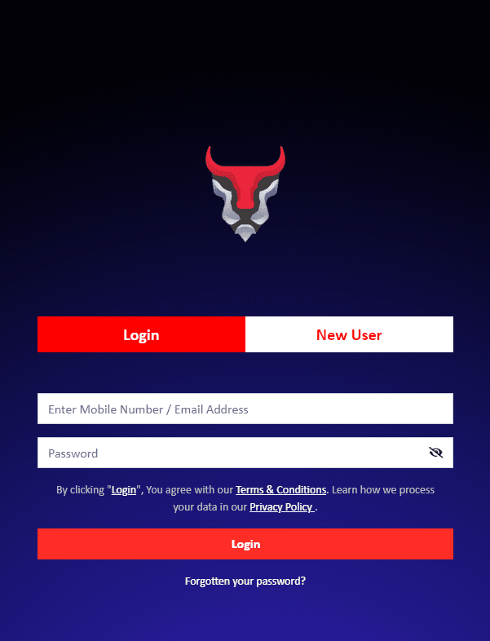
Figure 5.3 Login Screen

5.4 REGISTRATION SCREEN
The registration screen is for those users who are using this application for the first time. In registration a few basic details about the user will be asked and stored into the database of the application.
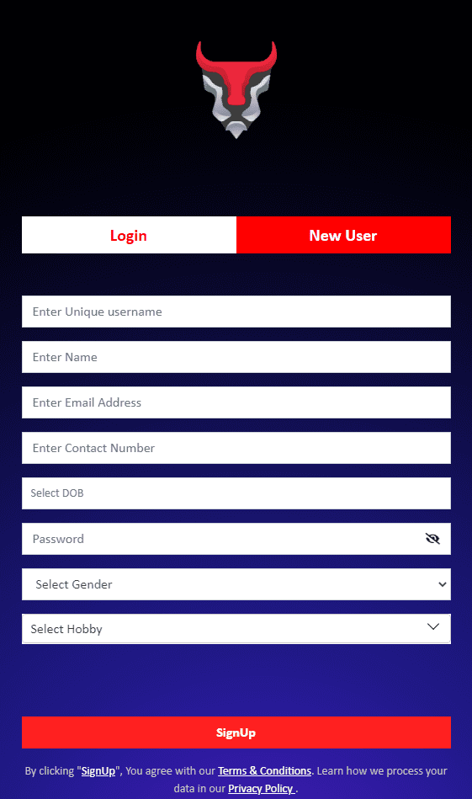
Figure 5.4.1 Registration Screen
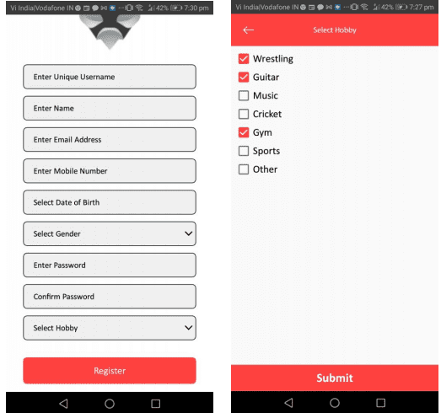
Figure 5.4.2 Mobile Application Register Screen

▪ Signup by filling requisite information in the fields. Unique username shall be without any space (can use ”_” for spaces. Please note that phone number/ email ids once provided can only be changed from settings post log-in.
▪ Phone number shall be verified by way of OTP and email id shall be verified post log-in from settings.
▪ User shall select his hobbies from the hobby list while sign-up which can be edited from settings. The same shall be used to provide better services to Dareit User

5.5 DASHBOARD
This is the first screen which will appear after login to the user. Here some very basic details about the application and navigation paths are provided.
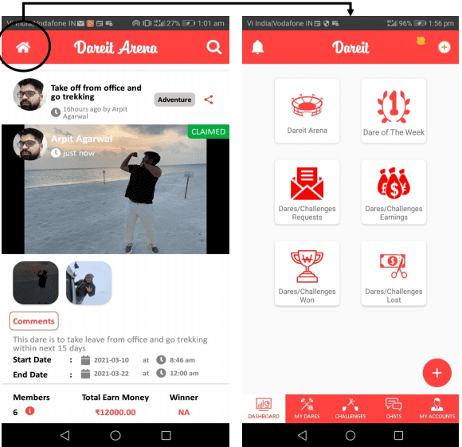
Figure 5.5 Dashboard

Once logged-in, user will be directed to the wall i.e. “Dareit Arena” where activities by various other users can be seen.
This includes public dares, friend dares and challenges.
▪ In Dareit Arena, users can see posts by other users, details of dares and challenges being played by other users like money involved, time of dare etc. Users can also comment on these dares and challenges and ask the participants various questions.
▪ Users can access the dashboard by clicking “Dashboard” in case of web and home icon in case of mobile app. Where users can see more options to use Dareit platform

5.6 Dare/Challenge LIST
This is the list of dares assigned by the admin of the application or the mentor. The user will be able to see the dare along with their detailed description and can update the status of the dare as complete/incomplete, and accordingly the color will be changed if dare is complete then it will show green otherwise red.
- Individual users can create or participate in friends and public dares and challenges created for a predefined prize money and time
- Users can upload daily updates and final claim proof on the platform for other participants and users to see and get motivated
- Users can also post other content on the platform like their daily activities by posting photos and videos on “The Wall”
- Admin users consist of institutions like schools, colleges, Corporates, clubs etc. or Individuals who want to organize Dares for Public or a selected group of people.
- Admin users will act as an organizer instead of a participant
- Admin user will have more options while creating the dare like creating only a participating dare instead of a competition
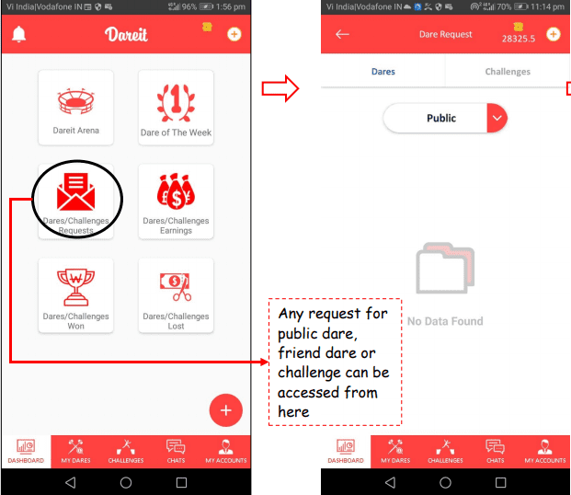
Figure 5.6 Dare/ Challenges List

5.7 Dare Creation Page
- Price per person to be filled in Creator can fill #tags while creating the dare/ challenge to expand users reach Dare/ challenge must be housed under a category.
- If a category does not exists, user can request admin to create one here or in settings
- In the case of Public Dare, users can float a dare in public and define the maximum number of participants.
- These public dare can be accepted by anyone interested in the dare User has the option to either show or hide a dare/ challenge for posting in Dareit Arena. By hiding, user can keep the dare/ Challenge private
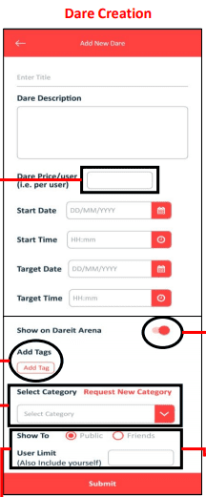
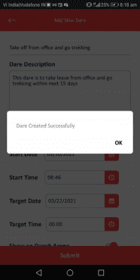

Figure 5.7 Dare Creation

5.8 Challenge Creation Page
If a user wants only another person to achieve a goal, he can create a challenge for a friend (public challenge is not allowed). Only the acceptor has to achieve a goal in this case.
In case of friends dare, User can select specific participants from his list of contacts or in his nearby vicinity (using GPS) and send a private request to those users instead of sending a public request to everyone
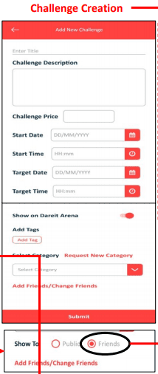
Figure 5.8 Challenge Creation

5.9 Challenge Creation Page
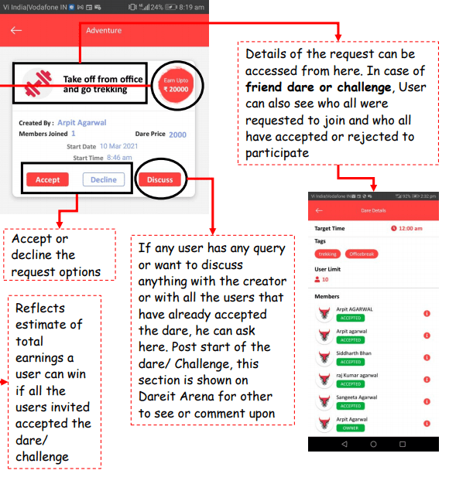
Figure 5.9 Dare/ Challenge Accept or Reject

- Accept or decline the request options
- Reflects estimate of total earnings a user can win if all the users invited accepted the dare/ challenge
- If any user has any query or want to discuss anything with the creator or with all the users that have already accepted the dare, he can ask here. Post start of the dare/ Challenge, this section is shown on Dareit Arena for other to see or comment upon
- Details of the request can be accessed from here. In case of friend dare or challenge, User can also see who all were requested to join and who all have accepted or rejected to participate
5.10 Landing Pages

- All ongoing dares and challenges can be accessed from here
- Final claim of Dares and challenges can be uploaded from here
- Day-to-day progress and proof that you are working to achieve the goal can be uploaded here
- Final claims uploaded by other users can be verified from here
- This is the remarks submitted claiming user along with his claim

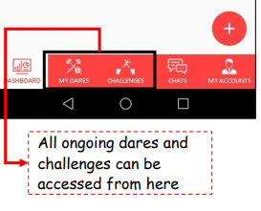
Figure 5.10 Landing Page Bar
5.11 Vote Page

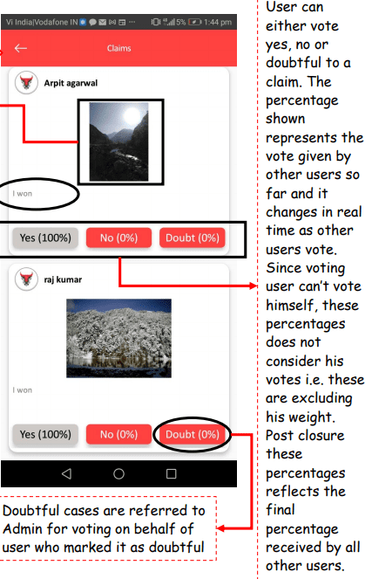
Figure 5.11 Vote Page
- Final claims uploaded by other users can be verified from here.
- This is the remarks submitted claiming user along with his claim
- Since voting user can’t vote himself, these percentages does not consider his votes i.e. these are excluding his weight
- Post closure these percentages reflect the final percentage received by all other users.
- Doubtful cases are referred to Admin for voting on behalf of user who marked it as doubtful
5.12 USER LIST

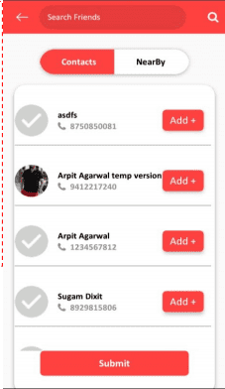
Figure 5.12 User List
The user list is useful in a sense to know about the registered users into the application. The admin does not need to check the user list from anywhere else and this list will also be available to everyone but only admin can assign dares/challenges or do any kind of changes into those registered users.
In case of friends dare, User can select specific participants from his list of contacts or in his nearby vicinity (using GPS) and send a private request to those users instead of sending a public request to everyone

5.13 USER PROFILE
User profile is the place where users can see all the details about them in this application like Id, email address, Name, Rank, Game Won,Money Earned, etc.

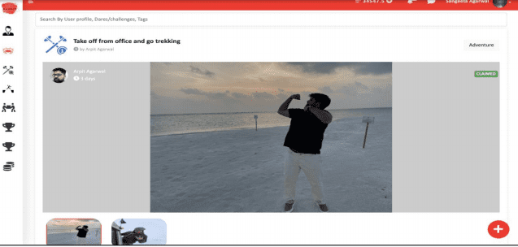
Figure 5.13 User Profile

▪ Once logged-in, user will be directed to the wall i.e. “Dareit Arena” where activities by various other users can be seen. This includes public dares, friend dares and challenges.
▪ In Dareit Arena, users can see posts by other users, details of dares and challenges being played by other users like money involved, time of dare etc. Users can also comment on these dares and challenges and ask the participants various questions.
▪ Users can access the dashboard by clicking “Dashboard” in case of web and home icon in case of mobile app. Where users can see more options to use Dareit platform

5.14 DareIT Arena Dashboard

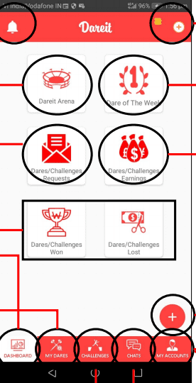
Figure 5.14 DareIT Arena Dashboard

Notification center of the Dareit Platform.
Take users to Dareit Arena.
All the request for Public dares, Friends dares and Challenges can be accessed here
All the dares and challenges that user has won/ lost are shown here
Dashboard access
Dares created and accepted by user that have already started or is about to start can be accessed from here
Challenges created and accepted by user that have already started or is about to start can be accessed from here
Users can purchase coins to take part in dare/ challenges from here. These will be deducted whenever user take part in any activity
Dare of the week is a feature of the Dareit platform where Dareit identifies the best dare every week based on internal identification criteria and offers additional benefits to winners
Dare/ Challenge Earnings shows total earnings and losses from dare/ challenges at one place
Users can Create new Dare or Challenge here
Options like settings, edit profile. request new category, Bank account, About us etc. can be accessed from here
Every time a dare/ challenge starts, a new group chat is created which can either be accessed particular dare/ challenge or from here.

CHAPTER 6
TESTING
Testing is an investment conducted to provide stakeholders with information about the quality of the software product or service under test. Software testing can also provide an objective, independent view of the software to allow the business to appreciate and understand the risk of software implementation. Test techniques include the process of executing a program or application with the intent of finding software bugs and verifying that the software product is fit for use.
Quality plays a crucial role in the success of a business. It is the degree of excellence which ensures some certain standards in a product. Based on quality, products can be categorized in two types, good quality products and bad quality products. A good quality product meets all the requirements of the customers or users whereas a bad or poor-quality product does not meet the expectations of the users.
The quality of a piece of software is based on the requirement specification document which is created before designing the software and can be defined as a blueprint of the software. To ensure a high level of quality of the software you need to do rigorous and effective software testing. The testing not only ensures that the software is consistent and bug-free, but it also checks whether the software meets the standards of quality and functionality as per expectations of the users before the software is released into the market. Software testing can be done through some testing models. Among these models, the verification and validation model (V model) is the most popular model of testing.
In this chapter, you learn about quality and its importance, as well as different methods used for maintaining quality. The chapter also discusses software quality metrics, software quality management system, software quality assurance, and quality standards. It also explains the psychology of software testing, the fundamental concepts of software testing and different levels of software testing. Towards the end, the chapter discusses the W model of software testing.
FOR TESTING WE NEED TEST STRATEGY AND TEST DESIGN
6.1 Definition of Quality
Quality is a general term that defines the degree, level, or extent up to which a product or service meets the requirements and specifications of the intended customers. The quality of a product/service is directly related to the satisfaction level of the customers. Quality depends on the following three aspects:
Customer requirement: Plays a crucial role in producing a product or in providing a service. A customer or user would buy a product or service if the product fulfills all the requirements. The product can be said to be of good quality in case it satisfies all the needs of customers.
Customer satisfaction: Implies that the quality of a product can be evaluated by the level of satisfaction that users derive from it. In other words, the better the quality of a product is, the more satisfied the users would be. Therefore, we can call customer satisfaction an accurate measure of quality.
Level of excellence: Ensures the degree of excellence in a product service. If the product fulfills all the requirements of the customers, it is considered a high-quality product. Based on availability of the product in the market, a customer can decide if the product is of good quality or poor quality.
After defining quality, let's discuss its importance.
6.2 Importance of Quality
Quality is of paramount importance for the success of an organization. The level of quality of products or services largely determines the volume of customers it attracts as well as the satisfaction level of the customers. By offering good quality products or services, an organization ensures a high degree of satisfaction among customers. And satisfied customers would continue doing business with the organization and would contribute to its growth and prosperity. On the other hand, poor quality products/services would discourage customers and that would have a negative impact on the organization. Therefore, quality is a key to the survival of an organization.
We know that the quality of products is important for an organization because it:
- Helps in maintaining high customer satisfaction as customers go for good quality products. Customer satisfaction, if nurtured properly, transforms into customer loyalty.
- Determines the brand value of a product. The brand value of the product is based on the quality maintained by the company. If an organization is producing high quality products, the brand value of the product would increase.
- Attracts the customers towards the features of a product. Usually, the customers invest in good quality and reliable products.
6.3 Managing Quality
Quality is managed at each level of the production process in an organization. It is not controlled by any individual person but a group working as a chain. In this chain, every person has a specific role to play. If a person does not perform to expectations, the quality is likely to suffer.
To manage quality an organization has to:
- Understand the requirements of the user: When a customer or user purchases a product, he/she expects it to be of a certain quality. It is one of the prerequisites of the user and.is taken very seriously by organizations. To provide quality products to its customers, an organization has to first have a clear understanding of the customers' requirements. Therefore, understanding the requirements of the users is the first step towards managing quality.
- Focus on product design: While designing a product an organization should maintain the quality because the design helps us in determining both appearance and functionalities of the product. Therefore, the organization should focus on the product design to ensure a good quality product.
- Make the product cost-effective: While purchasing a product, a customer always has three things in mind: price, functionality, and quality. For a product to be successful, it has to offer the maximum number of functionalities at a reasonable price and without compromising on quality. A customer always looks for cheaper options in the market.
- Make verification before delivery: Before delivering the product an organization should verify whether the product is according to the requirements of the customer or not. The product is of a good quality if it meets all the requirements,
5. Ensure customer satisfaction: An organization should analyze the satisfaction level of the customers on the basis of the feedback taken from the market. It should try to find out if the customers are satisfied with the quality of the product. If they are not satisfied it means that the product is not as per their requirements.
6.4 MOBILE TESTING
Mobile computing is probably the biggest technology change that has greatly impacted the tester’s realm of operations. Moving away from a desktop or laptop-based web application testing to a device or simulator/emulator-driven testing of web, native, or hybrid applications is a large change the testers are still getting used to. From a physical impact as well, testing on mobile devices with a hand-held has been a big change. Obviously, it is just not a device that has brought in the change. The device in combination with an application development mind-set and the overall application development process has created a very large test impact. Mobile applications have brought in a lot of focus on nonfunctional testing elements such as performance, security, and usability. Newer business models around m-commerce and content digitization have all triggered new testing opportunities. In fact, it is interesting to see business strategies such as discounts being offered only on the mobile app, mobile shopping spree, and large retailers such as Flipkart in India working toward a mobile-only presence. Crowdsourced testing strategy has become more prevalent given the need to test applications on a large range of mobile devices across realistic user scenarios. The tester himself is now encouraged to think like an end user. Mobile testing is forcing testers to think deeper and bring out optimization opportunities—for example, we have a homegrown tool at QA InfoTech, called Mobile Application Strategy Tool. This is a tool that will help you consider varied parameters and weigh in on them to make suggestions on what kind of testing should be done to maximize overall test coverage with a minimal set of tests to be run. This will also help you make a call on where the tests should be run (whether on physical devices or on simulators through a crowd team).
6.5 TEST STRATEGY
When a test effort was initially conceptualized as an independent activity to be performed by testers who were not involved in the development effort, the need for a test strategy came in. This is a document that talks about the product, its architecture, what are the varied test areas (for which test plans would subsequently be created), entry and exit criteria for the overall release, resource mapping identifying testers who would be working on varied components, what the group’s overall test and defect management practices would be, etc. This has served as a very valuable document in the waterfall days, helping the testers pause and understand the large context of what they were involved in, how each other’s work interlaced, what are some of the common practices in the team, etc.
6.5.1 Universal Rules
In the testing profession there is no silver bullet and no snake oil. Each and every project we are working on is completely different from all the others, even if they look very similar. You always need to approach them individually. Each project will require its own analysis, test approach and selection of tools and techniques. The real tester’s wisdom is to know exactly what and when to do in given circumstances. However, regardless of the problem you are working on, there are some universal rules that apply to all testing projects. Here they are:
1. Know your client’s needs.
2. Know where you are.
3. Know your enemies (faults).
4. Be reasonable and professional.
5. Be optimal.
6. Don’t give up.
7. Think
6.6 TEST DESIGN
A lot of emphasis was placed on designing test cases. While some teams left test cases at scenarios level, most teams would take in the scenarios from the test plans to elaborate them into a set of individual test cases of varying levels of detail. Some test cases were so detailed that a new tester coming into the test effort can merely review the test cases to understand application workflows. While such granularity helped ensure no confusion on what tests were executed and also to train new people, it also meant that so much more time was being spent on writing test cases, during which the tester could have actually tested the product. Maintenance was also a huge overhead where even for a small feature change, the tester had to spend a lot of time updating the test cases.
6.7 Approach Overview
6.7.1 Pre-processing.
Since the range invariants bug localization method needs to analyze the value information of variables when the program executes, it is necessary to instrument the program source code before the program is executed. And then execute the instrumented program according to the given inputs to obtain a series of test cases that contain execution path information and variable value information.
6.7.2 Test Case Optimization.
Our method is known for the error program, inputs and expected output results. Distinguished successful test cases and failure test cases by checking whether the execution results are the same as the expected results. In general, there are accidental correct test cases (CC) in successful test cases. If the number of such accidental correct test cases is large, the scope of the range invariants is increased, and the possibility of violating the range invariants is reduced, so that there are many false negatives. Therefore, we reduce the scope of range invariants by deleting accidental correct test cases, thereby increasing the possibility of violating invariants during the bug localization phase, thereby reducing false negatives. In this paper, we use the algorithm proposed by Masri to delete accidental correct test cases. And CCT is used to represent the set of successful test cases identified as CC.
6.7.3 Screening Key Variables.
In this paper, we first optimize the two variable evolution pattern detectors proposed in reference, and obtain two dynamic filtering mechanisms. Then we combine two dynamic filtering mechanisms and a static reduction mechanism to filter the variables in the program and obtain the set of key variables in the program.
6.7.4 Bug Localization.
First, we analyze the values of key variables in successful test cases, and obtain the range invariants of key variables statistically. Then, Software Bug Localization Based on Key Range Invariants 23 detect failure test cases. If the value of the key variable in failure test cases is not within the range of the corresponding invariant, the flag is violated. That is, the statement containing the variable is marked as a suspicious statement.
6.8 UI TESTING
User interface (UI) is a high return area when it comes to engaging the crowd. The crowd, especially an end user base-representing crowd, can provide strong UI feedback that aligns with its preferences. Since it aligns with the crowd’s preferences and touches a softer and intangible aspect of the end user, the crowd can potentially add more value in UI testing than even the internal test team. And since UI is an area of focus primarily for end user facing pages, screens, and sections, this is an area where the crowd adds very high value through its tests and feedback. Domain expertise is very important in this case, compared to the crowd’s end user representation.[5]
6.9 PERFORMANCE TESTING
This is an area that is given a lot of attention and focus in a test strategy in parallel to the core functional aspects. Typically, there is a separate team that focuses on performance testing the application from various angles, including load, stress, capacity and scalability, long haul, competitive baselining, etc. While the crowd cannot partake in all activities of performance testing due to infrastructure and system access limitations, if the product company diligently plans on how to use the crowd in this space, it can get some very valuable real time feedback on the application’s performance, which only the crowd can provide while still in the QA phase.[5]
6.10 TESTING OBJECTIVES
There are several rules that can serve as testing objectives. They are:
• Testing is the process of executing a program and finding a bug. A good test case is one that has a high probability of finding an undiscovered. A successful test is one that uncovers an undiscovered error .If testing is conducted successfully according to the objectives as stated above ,it would uncover errors in the software. Also testing demonstrates that software functions appear to the working according to the specification, that performance requirements appear to have been met.

6.10.1 UNIT TESTING
Unit testing is carried out screenwise, each screen being identified as an object. Attention is diverted to individual modules, independently to one another to locate errors .This has enabled the detection of errors in coding and logic .This is the first level of testing. In this, codes are written such that from one module , we can move on to the next module according to the choice we enter.

6.10.2 SYSTEM TESTING
In this, the entire system was tested as a whole with all forms, code, modules and class modules .System testing is the stage of implementation, which is aimed at ensuring that the system works accurately and efficiently before live operation commences. It is a series of different tests that verifies that all system elements have been properly integrated and perform allocated functions. System testing makes logical assumptions that if all parts of the system are correct, the goal will be successfully achieved. Testing is the process of executing the program with the intent of finding errors. Testing cannot show the absence of defects, it can only show that software errors are present.

6.10.3 INTEGRATION TESTING
This testing strategy combines all the modules involved in the system. After the independent modules are tested, dependent modules that use the independent modules are tested. This sequence of testing layers of dependent modules continues until the entire system is constructed .Through each module individually, they should work after linking them together. Data may be lost across the interface and one module can have adverse effects on another. Subroutines , after linking, may not do the desired function expected by the main routine. Integration testing is a systematic technique for constructing program structure while at the same time , conducting test to uncover errors associated with the interface. In the testing the programs are constructed and tested in the small segments.

6.10.4 WHITEBOX TESTING
White-box testing is concerned with testing the implementation of the program .The intent of this testing is not to exercise all the different input or output conditions but to exercise the different programming structures and data structures used in the program. White box testing is also called structural testing .To test the structure of a program, structural testing aims to achieve test cases that will force the desired coverage of different structures. Various criteria have been proposed for this there are three different approaches to structural testing: control flow-based testing, data flow-based testing, and mutation testing.

6.10.5 BLACKBOX TESTING
In black-box testing the structure of the program is not considered. Test cases are decided solely on the basis of the requirements or specifications of the program or module ,and the internals of the module or the program are not considered for selection of test cases .In black-box testing, the tester only knows the inputs that can be given to the system and what output the system should give. This form of testing is also called functional or behavioral testing.The most obvious functional testing procedure is exhaustive testing. One criterion for generating test cases is to generate them randomly. There are no formal rules for designing test cases for functional testing. In fact, there are no precise criteria for selecting test cases.

CHAPTER 7
ANGULAR SECURITY
7.1 Security
This topic describes Angular's built-in protections against common web-application vulnerabilities and attacks such as cross-site scripting attacks. It doesn't cover application-level security, such as authentication and authorization.
For more information about the attacks and mitigations described below, see OWASP Guide Project.
You can run the live example / download example in Stackblitz and download the code from there.
BEST PRACTICES
- Keep current with the latest Angular library releases. We regularly update the Angular libraries, and these updates may fix security defects discovered in previous versions. Check the Angular change log for security-related updates.
- Don't modify your copy of Angular. Private, customized versions of Angular tend to fall behind the current version and may not include important security fixes and enhancements. Instead, share your Angular improvements with the community and make a pull request.
- Avoid Angular APIs marked in the documentation as “Security Risk.” For more information, see the Trusting safe values section of this page.

7.2 Preventing cross-site scripting (XSS)
Cross-site scripting (XSS) enables attackers to inject malicious code into web pages. Such code can then, for example, steal user data (in particular, login data) or perform actions to impersonate the user. This is one of the most common attacks on the web.
To block XSS attacks, you must prevent malicious code from entering the DOM (Document Object Model). For example, if attackers can trick you into inserting a <script> tag in the DOM, they can run arbitrary code on your website. The attack isn't limited to <script> tags—many elements and properties in the DOM allow code execution, for example, <img onerror="..."> and <a href="javascript:...">. If attacker-controlled data enters the DOM, expect security vulnerabilities.

7.3 Angular’s cross-site scripting security model
To systematically block XSS bugs, Angular treats all values as untrusted by default. When a value is inserted into the DOM from a template binding, or interpolation, Angular sanitizes and escapes untrusted values. If a value was already sanitized outside of Angular and is considered safe, you can communicate this to Angular by marking the value as trusted.
Unlike values to be used for rendering, Angular templates are considered trusted by default, and should be treated as executable code. Never generate templates by concatenating user input and template syntax. Doing this would enable attackers to inject arbitrary code into your application. To prevent these vulnerabilities, always use the default AOT template compiler in production deployments.
An additional layer of protection can be provided through the use of Content security policy and Trusted Types. These web platform features operate at the DOM level which is the most effective place to prevent XSS issues because they can't be bypassed using other, lower-level APIs. For this reason, we strongly encourage developers to take advantage of these features by configuring the content security policy for their application and enabling trusted types enforcement.

7.4 Sanitization and security contexts
Sanitization is the inspection of an untrusted value, turning it into a value that's safe to insert into the DOM. In many cases, sanitization doesn't change a value at all. Sanitization depends on context: a value that's harmless in CSS is potentially dangerous in a URL.
Angular defines the following security contexts:
- HTML is used when interpreting a value as HTML, for example, when binding to innerHtml.
- Style is used when binding CSS into the style property.
- URL is used for URL properties, such as <a href>.
- Resource URL is a URL that will be loaded and executed as code, for example, in <script src>.
Angular sanitizes untrusted values for HTML, styles, and URLs; sanitizing resource URLs isn't possible because they contain arbitrary code. In development mode, Angular prints a console warning when it has to change a value during sanitization.

Sanitization example
The following template binds the value of htmlSnippet, once by interpolating it into an element's content, and once by binding it to the innerHTML property of an element:
src/app/inner-html-binding.component.html
content_copy
<h3>Binding innerHTML</h3>
<p>Bound value:</p>
<p class="e2e-inner-html-interpolated">{{htmlSnippet}}</p>
<p>Result of binding to innerHTML:</p>
<p class="e2e-inner-html-bound" [innerHTML]="htmlSnippet"></p>
Interpolated content is always escaped—the HTML isn't interpreted and the browser displays angle brackets in the element's text content.
For the HTML to be interpreted, bind it to an HTML property such as innerHTML. But binding a value that an attacker might control into innerHTML normally causes an XSS vulnerability. For example, one could execute JavaScript in a following way:
src/app/inner-html-binding.component.ts (class)
content_copy
export class InnerHtmlBindingComponent {
// For example, a user/attacker-controlled value from a URL.
htmlSnippet = 'Template <script>alert("0wned")</script> <b>Syntax</b>';
}
Angular recognizes the value as unsafe and automatically sanitizes it, which removes the script element but keeps safe content such as the <b> element.

7.5 Direct use of the DOM APIs and explicit sanitization calls
Unless you enforce Trusted Types, the built-in browser DOM APIs don't automatically protect you from security vulnerabilities. For example, documents, the node available through ElementRef, and many third-party APIs contain unsafe methods. In the same way, if you interact with other libraries that manipulate the DOM, you likely won't have the same automatic sanitization as with Angular interpolations. Avoid directly interacting with the DOM and instead use Angular templates where possible.
For cases where this is unavoidable, use the built-in Angular sanitization functions. Sanitize untrusted values with the DomSanitizer.sanitize method and the appropriate SecurityContext. That function also accepts values that were marked as trusted using the bypassSecurityTrust... functions, and will not sanitize them, as described below.

7.6 Trusting safe values
Sometimes applications genuinely need to include executable code, display an <iframe> from some URL, or construct potentially dangerous URLs. To prevent automatic sanitization in any of these situations, you can tell Angular that you inspected a value, checked how it was generated, and made sure it will always be secure. But be careful. If you trust a value that might be malicious, you are introducing a security vulnerability into your application. If in doubt, find a professional security reviewer.
To mark a value as trusted, inject DomSanitizer and call one of the following methods:
- bypassSecurityTrustHtml
- bypassSecurityTrustScript
- bypassSecurityTrustStyle
- bypassSecurityTrustUrl
- bypassSecurityTrustResourceUrl
Remember, whether a value is safe depends on context, so choose the right context for your intended use of the value. Imagine that the following template needs to bind a URL to a javascript:alert(...) call:
src/app/bypass-security.component.html (URL)
content_copy
<h4>An untrusted URL:</h4>
<p><a class="e2e-dangerous-url" [href]="dangerousUrl">Click me</a></p>
<h4>A trusted URL:</h4>
<p><a class="e2e-trusted-url" [href]="trustedUrl">Click me</a></p>
Normally, Angular automatically sanitizes the URL, disables the dangerous code, and in development mode, logs this action to the console. To prevent this, mark the URL value as a trusted URL using the bypassSecurityTrustUrl call:
src/app/bypass-security.component.ts (trust-url)
content_copy
constructor(private sanitizer: DomSanitizer) {
// javascript: URLs are dangerous if attacker controlled.
// Angular sanitizes them in data binding, but you can
// explicitly tell Angular to trust this value:
this.dangerousUrl = 'javascript:alert("Hi there")';
this.trustedUrl = sanitizer.bypassSecurityTrustUrl(this.dangerousUrl);
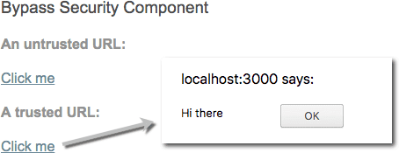
Figure 6 Localhost:3000
If you need to convert user input into a trusted value, use a component method. The following template allows users to enter a YouTube video ID and load the corresponding video in an <iframe>. The <iframe src> attribute is a resource URL security context, because an untrusted source can, for example, smuggle in file downloads that unsuspecting users could execute. So call a method on the component to construct a trusted video URL, which causes Angular to allow binding into <iframe src>:
src/app/bypass-security.component.html (iframe)
content_copy
<h4>Resource URL:</h4>
<p>Showing: {{dangerousVideoUrl}}</p>
<p>Trusted:</p>
<iframe class="e2e-iframe-trusted-src" width="640" height="390" [src]="videoUrl"></iframe>
<p>Untrusted:</p>
<iframe class="e2e-iframe-untrusted-src" width="640" height="390" [src]="dangerousVideoUrl"></iframe>
src/app/bypass-security.component.ts (trust-video-url)
content_copy
updateVideoUrl(id: string) {
// Appending an ID to a YouTube URL is safe.
// Always make sure to construct SafeValue objects as
// close as possible to the input data so
// that it's easier to check if the value is safe.
this.dangerousVideoUrl = 'https://www.youtube.com/embed/' + id;
this.videoUrl =
this.sanitizer.bypassSecurityTrustResourceUrl(this.dangerousVideoUrl);
}

7.7 Content security policy
Content Security Policy (CSP) is a defense-in-depth technique to prevent XSS. To enable CSP, configure your web server to return an appropriate Content-Security-Policy HTTP header. Read more about content security policy at the Web Fundamentals guide on the Google Developers website.

Enforcing Trusted Types
We recommend the use of Trusted Types as a way to help secure your applications from cross-site scripting attacks. Trusted Types is a web platform feature that can help you prevent cross-site scripting attacks by enforcing safer coding practices. Trusted Types can also help simplify the auditing of application code.
Trusted Types might not yet be available in all browsers your application targets. In the case your Trusted-Types-enabled application runs in a browser that doesn't support Trusted Types, the functionality of the application will be preserved, and your application will be guarded against XSS by way of Angular's DomSanitizer. See caniuse.com/trusted-types for the current browser support.
To enforce Trusted Types for your application, you must configure your application's web server to emit HTTP headers with one of the following Angular policies:
- angular - This policy is used in security-reviewed code that is internal to Angular, and is required for Angular to function when Trusted Types are enforced. Any inline template values or content sanitized by Angular is treated as safe by this policy.
- angular#unsafe-bypass - This policy is used for applications that use any of the methods in Angular's DomSanitizer that bypass security, such as bypassSecurityTrustHtml. Any application that uses these methods must enable this policy.
- angular#unsafe-jit - This policy is used by the JIT compiler. You must enable this policy if your application interacts directly with the JIT compiler or is running in JIT mode using the platform browser dynamic.
You should configure the HTTP headers for Trusted Types in the following locations:
- Production serving infrastructure
- Angular CLI (ng serve), using the headers property in the angular.json file, for local development and end-to-end testing
- Karma (ng test), using the customHeaders property in the karma.config.js file, for unit testing
The following is an example of a header specifically configured for Trusted Types and Angular:
content_copy
Content-Security-Policy: trusted-types angular; require-trusted-types-for 'script';
The following is an example of a header specifically configured for Trusted Types and Angular applications that use any of the methods in Angular's DomSanitizer that bypasses security.
content_copy
Content-Security-Policy: trusted-types angular angular#unsafe-bypass; require-trusted-types-for 'script';
The following is an example of a header specifically configured for Trusted Types and Angular applications using JIT:
content_copy
Content-Security-Policy: trusted-types angular angular#unsafe-jit; require-trusted-types-for 'script';
7.8 Use the AOT template compiler
The AOT template compiler prevents a whole class of vulnerabilities called template injection, and greatly improves application performance. The AOT template compiler is the default compiler used by Angular CLI applications, and you should use it in all production deployments.
An alternative to the AOT compiler is the JIT compiler which compiles templates to executable template code within the browser at runtime. Angular trusts template code, so dynamically generating templates and compiling them, in particular templates containing user data, circumvents Angular's built-in protections and is a security anti-pattern. For information about dynamically constructing forms in a safe way, see the Dynamic Forms guide.

7.9 Server-side XSS protection
HTML constructed on the server is vulnerable to injection attacks. Injecting template code into an Angular application is the same as injecting executable code into the application: it gives the attacker full control over the application. To prevent this, use a templating language that automatically escapes values to prevent XSS vulnerabilities on the server. Don't generate Angular templates on the server side using a templating language; doing this carries a high risk of introducing template-injection vulnerabilities.

7.10 HTTP-level vulnerabilities
Angular has built-in support to help prevent two common HTTP vulnerabilities, cross-site request forgery (CSRF or XSRF) and cross-site script inclusion (XSSI). Both of these must be mitigated primarily on the server side, but Angular provides helpers to make integration on the client side easier.

Cross-site request forgery
In a cross-site request forgery (CSRF or XSRF), an attacker tricks the user into visiting a different web page (such as evil.com) with malicious code that secretly sends a malicious request to the application's web server (such as example-bank.com).
Assume the user is logged into the application at example-bank.com. The user opens an email and clicks a link to evil.com, which opens in a new tab.
The evil.com page immediately sends a malicious request to example-bank.com. Perhaps it's a request to transfer money from the user's account to the attacker's account. The browser automatically sends the example-bank.com cookies (including the authentication cookie) with this request.
If the example-bank.com server lacks XSRF protection, it can't tell the difference between a legitimate request from the application and the forged request from evil.com.
To prevent this, the application must ensure that a user request originates from the real application, not from a different site. The server and client must cooperate to thwart this attack.
In a common anti-XSRF technique, the application server sends a randomly generated authentication token in a cookie. The client code reads the cookie and adds a custom request header with the token in all subsequent requests. The server compares the received cookie value to the request header value and rejects the request if the values are missing or don't match.
This technique is effective because all browsers implement the same origin policy. Only code from the website on which cookies are set can read the cookies from that site and set custom headers on requests to that site. That means only your application can read this cookie token and set the custom header. The malicious code on evil.com can't.
Angular's HttpClient has built-in support for the client-side half of this technique. Read about it more in the HttpClient guide.
For information about CSRF at the Open Web Application Security Project (OWASP), see Cross-Site Request Forgery (CSRF) and Cross-Site Request Forgery (CSRF) Prevention Cheat Sheet. The Stanford University paper Robust Defenses for Cross-Site Request Forgery is a rich source of detail.
See also Dave Smith's easy-to-understand talk on XSRF at AngularConnect 2016.

Cross-site script inclusion (XSSI)
Cross-site script inclusion, also known as JSON vulnerability, can allow an attacker's website to read data from a JSON API. The attack works on older browsers by overriding native JavaScript object constructors, and then including an API URL using a <script> tag.
This attack is only successful if the returned JSON is executable as JavaScript. Servers can prevent an attack by prefixing all JSON responses to make them non-executable, by convention, using the well-known string ")]}',\n".
Angular's HttpClient library recognizes this convention and automatically strips the string ")]}',\n" from all responses before further parsing.
For more information, see the XSSI section of this Google web security blog post.

Auditing Angular applications
Angular applications must follow the same security principles as regular web applications, and must be audited as such. Angular-specific APIs that should be audited in a security review, such as the bypassSecurityTrust methods, are marked in the documentation as security sensitive.

CHAPTER 8
LIMITATIONS
8.1 LIMITATIONS
The limitations of the study are those characteristics of design or methodology that impacted or influenced the application or interpretation of the results of your study. They are the constraints on generalizability and utility of findings that are the result of the ways in which you chose to design the study and/or the method used to establish internal and external validity.
Every project in this world have some limitations, similarly our project also has some of them:
- Internet based, without internet users cannot access its tools.
- Server Dependent
- User Details must be correct
8.2 FUTURE SCOPE
The future scope of the project are as follows:
- Providing better User Experience
- Additional features like chat support
- Reduce Load Time
8.3 FUTURE ENHANCEMENT
- Provide Notification to the user
- More reliability on application
- Graphics enhancements

CHAPTER 9
CONCLUSION
Working on the project was a good experience. Working together in a team helped us to communicate better. We understood the importance of planning and designing as a part of software development.
Developing the project has helped us to gain some experience on real time development procedures.
This is an application for those users that requires assigning daily basic tasks to students or to employees. With the help of this application the physical reporting to mentor for getting new tasks and for updating about task status is eliminated.

CHAPTER 10
REFERENCES

- Nate Murray (ng-book: The Complete Guide to Angular)
1st Edition
Publisher: Auerbach Publications
https://www.taylorfrancis.com/books/9780429111600
- Mosh Hamedani (The Complete Angular Course: Beginner to Advanced)
1st Edition
Publisher: Springer, Cham
https://link.springer.com/chapter/10.1007/978-3-319-73195-7_3
- Vishwas Gopinath (Angular - Mastering the Basics)
1st Edition
Publisher: Auerbach Publications
https://www.taylorfrancis.com/books/9780429111600
- A.V. Dattatyeta Rao (Angular Statistics)
Publisher: Chapman and Hall
https://ebooks.wileyindia.com/epubreader/android-programming
- Preston Zhang (Practice guide to SQL, T-SQL and MySQL)
1st Edition
Publisher: CRC Press
https://ebooks.wileyindia.com/epubreader/beginning-android-programming-studio
- Lin Ma (Software Bug Localization Based on Key Range Invariants)
Research paper from: School of Information Science and Technology, Zhejiang Sci-Tech University, Hangzhou 310019, Zhejiang, China
https://link.springer.com/content/pdf/10.1007%2F978-3-030-04272-1_2.pdf
- Mukesh Sharma (Leveraging the Wisdom of the Crowd in Software Testing)
1st Edition
Publisher: Auerbach Publications
https://www.taylorfrancis.com/books/9780429189722
- Oliver Mesly (Project Feasibility)
1st Edition
Publisher: Boca Raton
https://www.taylorfrancis.com/books/9781315295251
- Rajesh K Maurya (Software testing, ISBN 9789350044001,
Publisher: Wiley
https://ebooks.wileyindia.com/pdfreader/software-testing)
- Rajini Padmanabhan (Leveraging the Wisdom of the Crowd in Software Testing)
1st Edition
Publisher: Auerbach Publications
https://www.taylorfrancis.com/books/9780429189722
- Swati R Maurya (Software testing, ISBN 9789350044001,
Publisher: Wiley
https://ebooks.wileyindia.com/pdfreader/software-testing)
- Zuohua Ding (Software Bug Localization Based on Key Range Invariants)
Research paper from: School of Information Science and Technology, Zhejiang Sci-Tech University, Hangzhou 310019, Zhejiang, China
https://link.springer.com/content/pdf/10.1007%2F978-3-030-04272-1_2.pdf
- https://www.tektutorialshub.com/angular-tutorial/

- https://pub.dev/

- https://en.wikipedia.org/

- https://stackoverflow.com/

- https://medium.com/

- https://github.com/

